**State wise farmers adopted/benefitted through micro-irrigation**



**BTech/II Year CSE/III Semester**

**19CSE202/Database Management Systems**

**Case Study**

|  |  |
| --- | --- |
| Rollno | Name |
| CB.EN.U4CSE21123 | **H Akshaya** |
| CB.EN.U4CSE21156 | **Shivani K** |
| CB.EN.U4CSE21159 | **Sravya Mukkara** |
| CB.EN.U4CSE21169 | **Vupalapate Divya** |
|  |  |

**Department of Computer Science and Engineering**

**Amrita School of Computing, Coimbatore**

**Amrita Vishwa Vidyapeetham**

**2022 -2023 Odd Semester**

**Table of Contents**

**Title                                                                                                     Page number**

Chapter1 Introduction………………………………………………………………………………………………………………………2

Abstract………………………………………………………………………………………………………………………………………………………………….

Chapter 2 Logical Database and ER design……………………………………………………………………………………………………………3

Entities……………………………………………………………………………………………………………………………………………………………………

Attributes……………………………………………………………………………………………………………………………………………………………….

Relationships…………………………………………………………………………………………………………………………………………………………

ER Diagram……………………………………………………………………………………………………………………………………………………………

Chapter 3 ER to Relational Schema Mapping………………………………………………………………………………………………………….5

Chapter 4 User Interface Screens……………………………………………………………………………………………………………………………6

Chapter 5 Normalization………………………………………………………………………………………………………………………………………….7

Chapter 6 Database Connectivity………………………………………………………………………………………………………………………………22

Chapter 7 Analysis of Data and Reports generated…………………………………………………………………………………………….…….27

References……………………………………………………………………………………………………………………………………………………………………30

**Chapter 1**

Introduction

Fortunately for farmers with irrigation, new technology improves their ability to manage water, labor and energy more efficiently while giving crops necessary moisture for profitable yields. Agricultural water consumption has become a major concern around the world. Farmers in general still lack proper tools and incentives to understand agricultural water consumption, actual irrigation applications, crop yield response to various water management methods, and so on.

**Abstract**

A contemporary irrigation technique is the micro-irrigation system. This is a process in which we administer water slowly. Usually given in the form of single droplets, continuous drops, streams, etc. Micro-irrigation system is popular these days for its low cost and water-efficiency. Through drippers, sprinklers, foggers, and other emitters, water is irrigated on the surface or beneath the ground using this technique. Losses are unavoidable in conventional irrigation techniques; however, micro-irrigation, with its water-saving strategy, has made it possible for higher water use efficiency of about 75–95%. Fertigation leads to balanced nutrient application, a 7–42% decrease in fertiliser requirements. Different irrigation information fields can be stored in the design database to control the period and required amount. Using online weather forecast, future irrigation decision is determined by the comparison between the field water availability simulated by the system and the lower limit of the soil moisture for irrigation. By which, farmers may acquire the irrigation decision support: when irrigation is needed and how much water is necessary. 27 states (including UT) in India have less than 30% micro-irrigation system and within these states, 23 states have less than 15% Micro-irrigation. Only Sikkim, Andhra Pradesh, Karnataka, and Maharashtra have more than half of their net cultivable area under micro irrigation. Surprisingly Uttar Pradesh is the largest producer of Sugarcane, a water-intensive crop, but it has only 1.5% area under micro irrigation, similarly, Punjab has only 1.2 %.

**Chapter 2**

Logical Database Design  :

**Entities**

* State
* Soil
* Irrigation
* Firm
* Farmers
* climate

**Attributes**

* **State :** name, soil_type, area,crops,%_increase_in_GDP
* **Soil :** soil_type, pH, minerals(macro, micro), chemical_content,flow_rate(water, nutrients)
* **Irrigation:** irrigation_type, equipment, cost_per_unit, efficiency, %decrease_in_lossofwater
* **Firm :** firm_name, private, state_govt,central_govt, fund, farmer_type, irrigation_type,farmer_id (FK)
* **Farmers:** farmer_id , farmer_type, fund
* **Climate :** relative_humidity, precipitation, irrigation_type,temperature(air,H2O)

**Relationships**

* State covers soil
* State allied firm
* States have farmers
* State under climate
* State incorporates irrigation
* Soil influence irrigation
* Irrigation depends upon climate
* Firm focuses on irrigation
* Firm supports farmers

**ER Diagram**

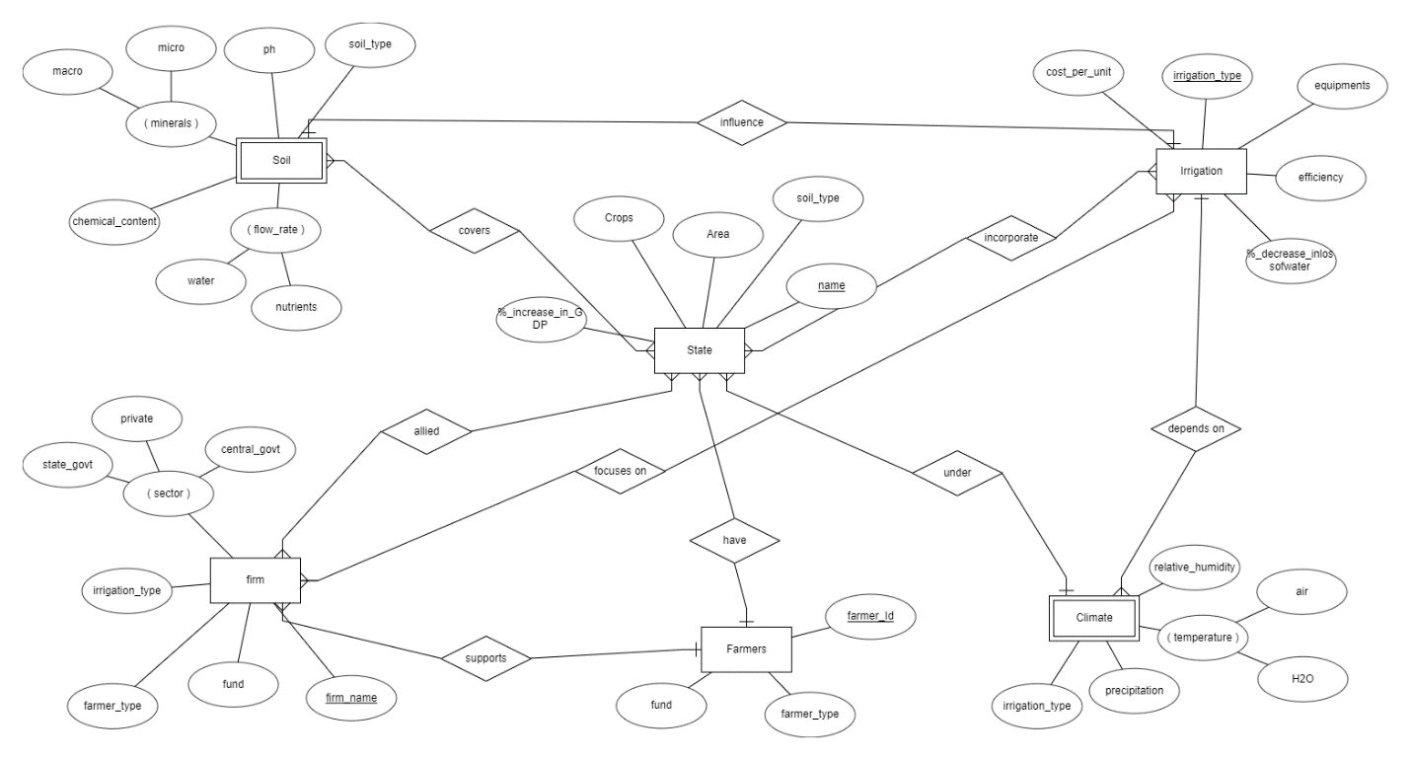

**Chapter 3   ER to Relational Schema Mapping**

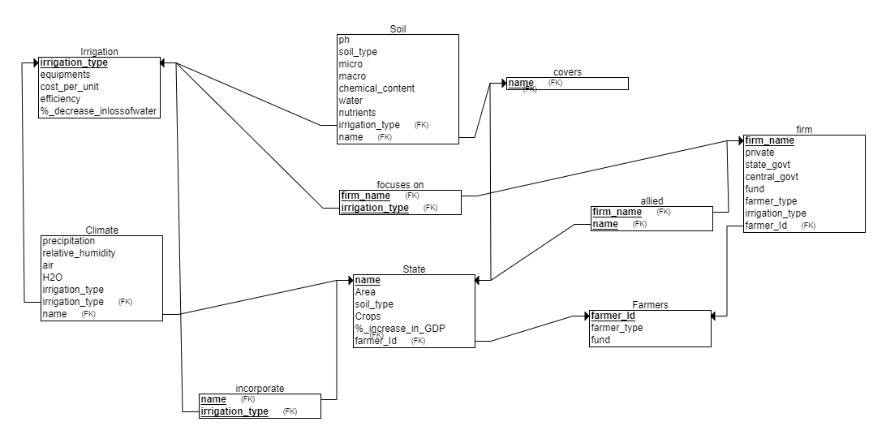

**Chapter 4 User Interface Screens**

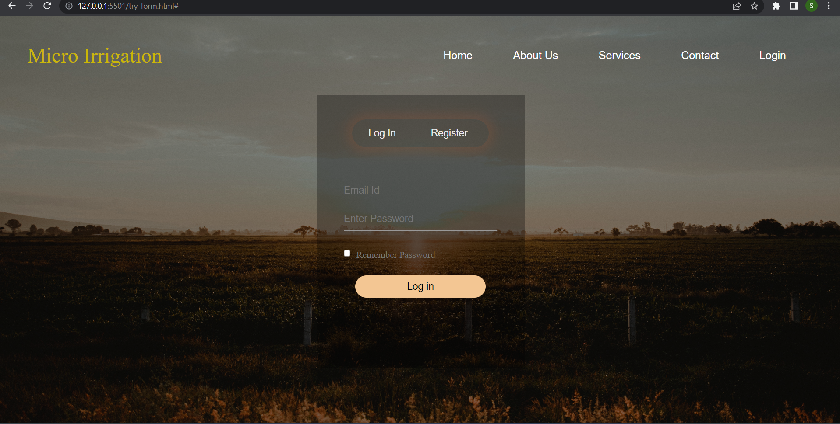

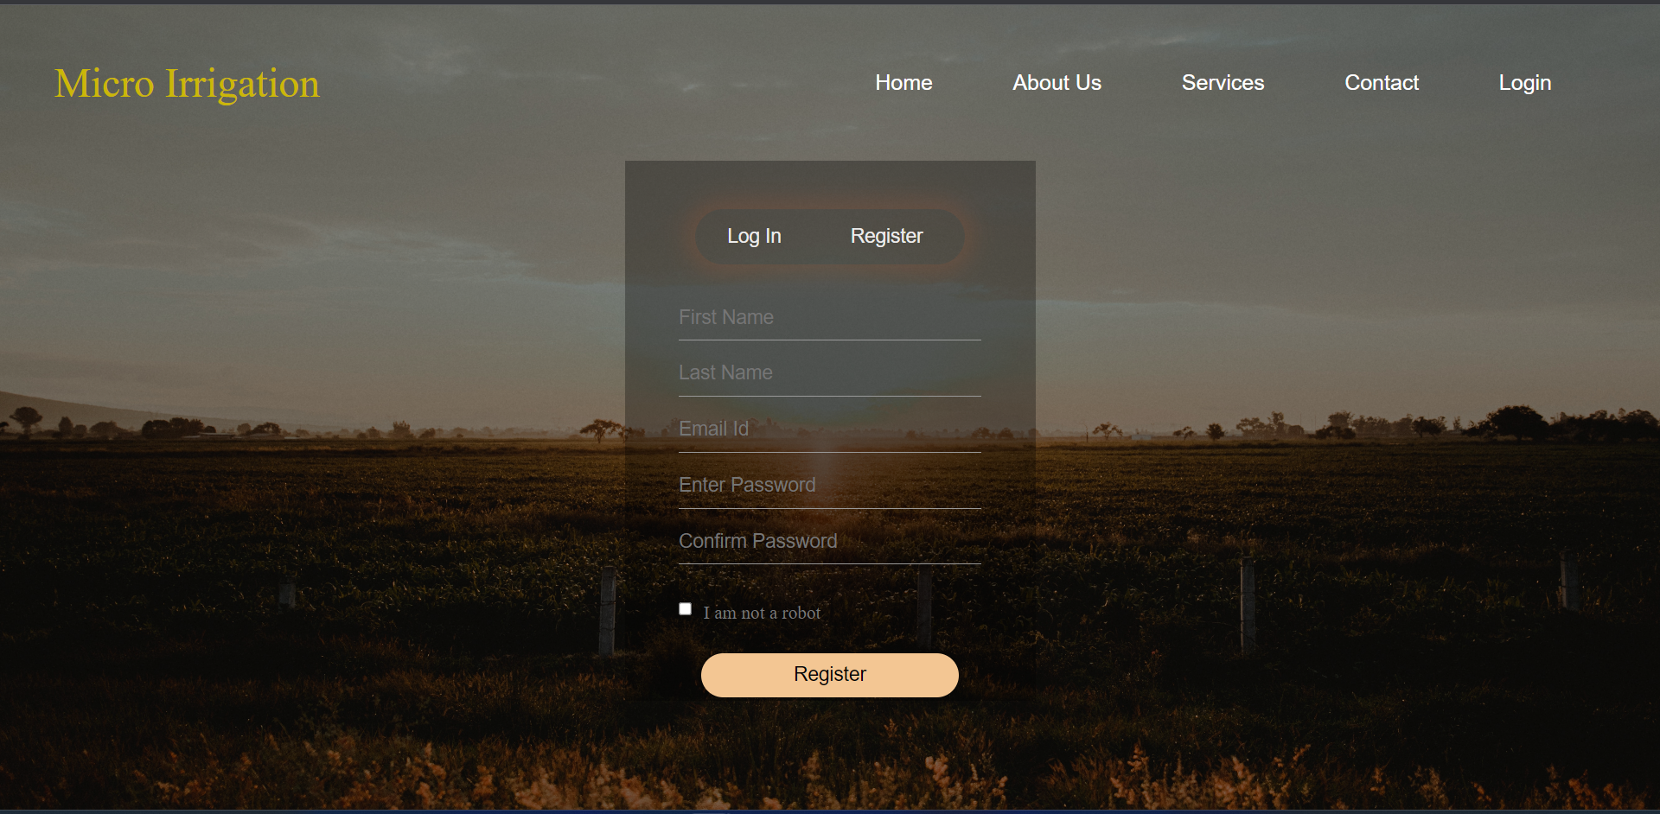

# Case study Review-2

# Chapter 5 Normalization

**FUNCTIONAL DEPENDENCIES**

1. Farmer_Id🡪Farmer_Name
2. Farmer_Id🡪Farmer_type
3. Temperature🡪preciptation
4. Temperature,relative_humidity🡪precipitation
5. Soil_name🡪ph
6. Soil_name🡪irrigation_type
7. Soil_name,soil_type🡪irrigation_type
8. Soil_name🡪chemical_content
9. Irrigation_type🡪no_of_equipments
10. Irrigation_type🡪 %_decrease_inlossofwater
11. Irrigation_type🡪efficiency,cost_per_unit
12. efficiency🡪%_decrease_inlossofwater
13. Firm_Name🡪Sector
14. State_name🡪area
15. State_name🡪soil_type
16. State_name🡪%_increase_in_GDP
17. Firm_name,farmer_type🡪fund
18. soil name,soil_type, ph,rich_nutrient🡪 chemical content
19. soil name,soil_type, ph,rich_nutrient 🡪range of water
20. soil name,soil_type, ph,rich_nutrient 🡪irrigation type

**ATTRIBUTE CLOSURE**

1. {Farmer_id}+={ Farmer_Name, Farmer_type,Farmer_id}
2. {Farmer_Name}+={ Farmer_Name}
3. {Farmer_type}+={Farmer_type}
4. {Fund}+={ Fund}
5. {irrigation_type}+={ irrigation_type,cost_per_unit , no_of_equipments, %_decrease_inlossofwater,efficiency}
6. {cost_per_unit}+={ cost_per_unit}
7. { no_of_equipments}+={ no_of_equipments}
8. {%_decrease_inlossofwater}+={%_decrease_inlossofwater}
9. {precipitation}+={precipitation}
10. {relative_humidity}+={ relative_humidity}
11. {temperature}+={precipitation,temperature}
12. {soil_name}+={soil_name,ph,chemical_content,irrigation_type, range_of_water_content, no_of_equipments, %_decrease_inlossofwater, cost_per_unit}
13. {soil_type}+={soil_type, range_of_water_content}
14. {ph}+={ph,chemical_content}
15. {chemical_content}+={chemical_content}
16. {Rich_nutrient}+={ Rich_nutrient}
17. {avg_range_of_water_content}+={ avg_range_of_water_content}
18. {%_increase_in_GDP}+={%_increase_in_GDP}
19. {state_name}+={state_name,area,soil_type}
20. {area}+={area}
21. {firm_name}+={firm_name,Sector}
22. {sector}+={sector}
23. {efficiency}+={ efficiency, %_decrease_inlossofwater}

**CANONICAL COVER**

1. Farmer_Id -> Farmer_Name

2. Farmer_Id 🡪 Farmer_type

3. Temperature 🡪 preciptation

4. relative_humidity 🡪 precipitation

5. Soil_name 🡪 ph

6. Soil_name 🡪 irrigation_type

7. soil_type 🡪 irrigation_type

8. Soil_name 🡪 chemical_content

9. Irrigation_type 🡪 no_of_equipments

10. Irrigation_type 🡪 %_decrease_inlossofwater

11. Irrigation_type 🡪 efficiency,cost_per_unit

12. efficiency 🡪 %_decrease_inlossofwater

13. Firm_Name 🡪Sector

14. State_name 🡪 area

15. State_name 🡪 soil_type

16. State_name 🡪 %_increase_in_GDP

17. Firm_name,farmer_type 🡪 fund

18. soil name,soil_type, ph,rich_nutrient 🡪 chemical content

19. soil name,soil_type, ph,rich_nutrient 🡪 range of water

20. soil name,soil_type, ph,rich_nutrient 🡪 irrigation type

**SUPER KEYS**

* (Firm_name,Sector,irrigation_type,Farmer_type,Fund) as superkeys for relation firm.
* Irrigation_type as superkey for relation irrigation.
* (soil name, type, ph, nutrient) as superkey for relation soil.
* (Temperature,relative_humidity) as superkey for relation climate.
* Farmer_id as superkey for relation farmer.
* State_name as superkey for relation state.

**ANOMALIES**

Updation anomaly is present in relation firm, for example, when in need of updation of large farming type,multiple tuples need to be updated along with it too.

Deletion anomaly is also present in relation firm, for example, when you remove an irrigation type details about a firm is deleted along with it.

**1NF**

The conditions for 1NF are:

1. The relation must have a primary key.
2. The relation must only store atomic values.
3. The relation must not have any similar columns [columns storing similar information].

The relation is not in 1st normal form as we cant find primary key as far as our knowledge. It doesn’t satisfy the 2nd condition also as it stores multiple values.

For example, rich nutrient, ph groups has multiple values stored.

**PARTIAL DEPENDECIES**

1. Temperature,relative_humidity🡪precipitation
2. Soil_name,soil_type🡪irrigation_type
3. Firm_name,farmer_type🡪fund
4. soil name,soil_type, ph,rich_nutrient🡪 chemical content
5. soil name,soil_type, ph,rich_nutrient 🡪range of water
6. soil name,soil_type, ph,rich_nutrient 🡪irrigation type

**TRANSITIVE DEPENDENCIES**

1. Irrigation_type🡪efficiency,cost_per_unit
2. efficiency🡪%_decrease_inlossofwater
3. Irrigation_type🡪 %_decrease_inlossofwater

The 3rd point can be removed because of transitive dependency.

**DECOMPOSITION**

**2NF:**

For the relation to be in 2NF, it must not have any partial dependencies. When A 🡪 B, and B is functionally dependent on A, but B can also be determined by any other proper subset of A, then

A 🡪 B is a partial dependency.

**3NF:**

For the relation to be in 3NF, it must not have any transitive dependencies. A functional dependency in a database is an indirect relationship between values in the same table that causes a functional dependency. It occurs when the value of a non-key attribute is functionally dependent on the value of another non-key attribute.

**BCNF:**

For the relation to be in BCNF, it must already be in 3NF. For every functional dependency X 🡪 Y, X must be a super key.

Table: Firm

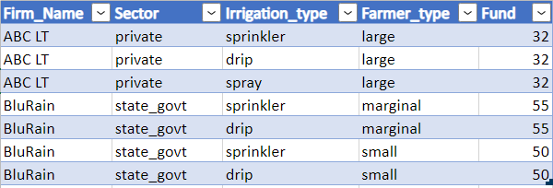

The relation firm is in 1st NF but since it has partial dependency it is not in 2nd NF. So we decompose the table to:

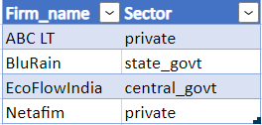 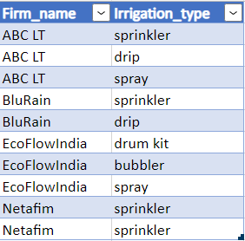

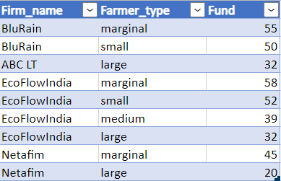

After decomposing the table firm the relations now satisfy all normal forms including BCNF.

Table: Irrigation

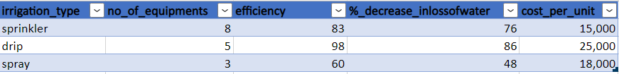

The relation is in 1st and 2nd normal forms.

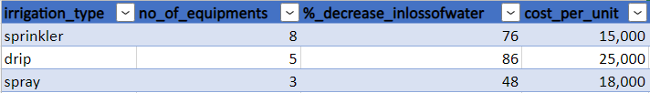

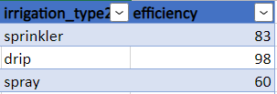

After decomposition the relation satisfies the condition of 3NF and BCNF.

Table: Soil



The relation is not in 1st NF as it doesn’t satisfy the condition but on decomposition,

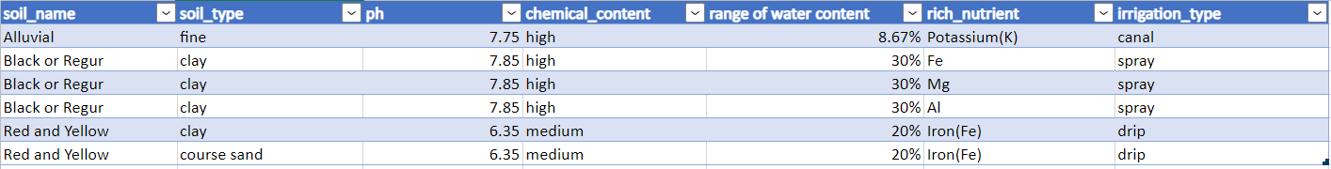

The above relation meet the requirements for 1st NF.

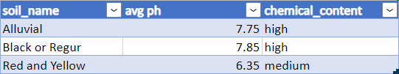

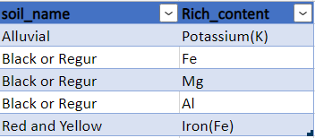

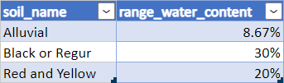

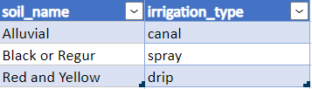

Upon decomposition the relations now meet the requirements for 3NF as well as BCNF.

Table: Climate

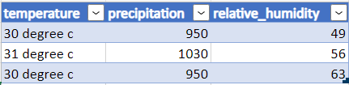

The relation climate is in 1st NF. To meet the requirements of 2nd NF ,3rd NF and BCNF the relation is decomposed into

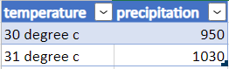 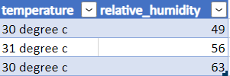

Now the relations meet the requirements for BCNF.

Table: Farmer

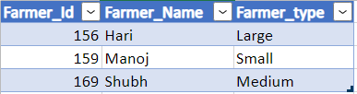

The relation meets the requirement of all 3 normal forms and BCNF.

Table: State

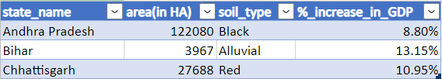

The relation meets the requirement of all 3 normal forms and BCNF.

**DEPENDENCY DIAGRAM**

Table: climate

|  |  |  |
| --- | --- | --- |
| temperature | precipitation | Relative_humidity |

Table: State

|  |  |  |  |
| --- | --- | --- | --- |
| State_name | Area | Soil_type | %_increase_in_GDP |

Table: Firm

|  |  |  |  |  |
| --- | --- | --- | --- | --- |
| Firm_Name | Sector | Irrigation_type | Farmer_type | Fund |

Table: Irrigation

|  |  |  |  |  |
| --- | --- | --- | --- | --- |
| Irrigation_type | No_of_eqipments | efficiency | %_decrease_in_loss_of_water | cost_per_unit |

Table: Soil

|  |  |  |  |  |  |  |
| --- | --- | --- | --- | --- | --- | --- |
| Soil_name | Soil_type | Avg_ph | Chemical_  content | Range_of_water_  content | Rich_nutrient | Irrigation_type |

Table: Farmer

|  |  |  |
| --- | --- | --- |
| Farmer_Id | Farmer_Name | Farmer_type |

**Lossless Decomposition**

Attributes:

1. Soil_name
2. Soil_type
3. Ph
4. Chemical_content
5. Avg_range_of_water_content
6. Rich nutrient
7. Irrigation_type
8. Temperature
9. Precipitation
10. Relative_humidity
11. Farmer_id
12. Farmer_name
13. Farmer_type
14. No_of_equipments
15. Efficiency
16. %_decrease_inlossofwater
17. Cost_per_unit
18. Firm_name
19. Sector
20. Fund
21. State_name
22. area
23. %_increase_in_GDP

Relations:

R1: (Firm_name,Sector,irrigation_type,farmer_type,fund)

R2: (irrigation_type,no_of_equipments,efficiency,%_decrease_inlossofwater,cost_per_unit,soil_type)

R3: (Soil_name,Soil_type,avg_ph,chemical_content, Avg_range_of_water_content,rich_nutrient,irrigation_type,state_name,relative_humidity)

R4: (temperature,precipitation,relative_humidity,irrigation_type)

R5: (Farmer_id,farmer_name,farmer_type,soil_type,state_name,fund)

R6: (state_name,area,soil_type, %_increase_in_GDP)

|  |  |  |  |  |  |  |  |  |  |  |  |  |  |  |  |  |  |  |  |  |  |  |  |
| --- | --- | --- | --- | --- | --- | --- | --- | --- | --- | --- | --- | --- | --- | --- | --- | --- | --- | --- | --- | --- | --- | --- | --- |
|  | A | B | C | D | E | F | G | H | I | J | K | L | M | N | O | P | Q | R | S | T | U | V | W |
| R1 |  |  |  |  |  |  | α | Β | Β | Β |  |  | α | Β | Β | Β | Β | α | α | α | Β |  |  |
| R2 |  | α |  |  |  |  | α | Β | Β | Β |  |  |  | α | α | α | α |  |  |  |  |  |  |
| R3 | α | α | α | α | α | α | α | Β | Β | α | Β | Β | Β | Β | Β | Β | Β | Β | Β | Β | α | α | α |
| R4 |  |  |  |  |  |  | α | α | α | α |  |  |  |  |  |  | α | α | Β |  |  |  |  |
| R5 |  | α |  |  |  |  | Β |  |  |  | α | α | α |  |  |  |  |  |  | α | α |  |  |
| R6 |  | α |  |  |  |  | Β |  |  |  | Β | Β |  |  |  |  |  |  |  |  | α | α | α |

The table firm is decomposed into :

R11: (firm_name,sector), R12: (firm_name,irrigation_type),

R13: (farmer_type,firm_name,fund)

|  |  |  |  |  |  |
| --- | --- | --- | --- | --- | --- |
|  | R | S | G | M | T |
| R11 | α | α |  |  |  |
| R12 | α | B | α | B | B |
| R13 | α | B |  | α | α |

Since row2 is filled the decomposition is lossless.

The relation irrigation is decomposed into:

R21: (irrigation_type,no_of_equipments,%_decrease_inlossofwater,cost_per_unit) , R22: (irrigation_type,efficiency)

|  |  |  |  |  |  |
| --- | --- | --- | --- | --- | --- |
|  | G | N | O | P | Q |
| R21 | α | α | B | α | α |
| R22 | α |  | α |  |  |

Since the first row is filled the decomposition is lossless.

The relation soil is decomposed into:

R31: (soil_name,soil_type,avg_ph,chemical_content), R32: (soil_name,irrigation_type), R33: (soil_name,soil_type, Rich_nutirent),R34: (soil_name,avg_range_water_content), R35: (soil_name,rich_nutrient).

|  |  |  |  |  |  |  |  |
| --- | --- | --- | --- | --- | --- | --- | --- |
|  | A | B | C | D | E | F | G |
| R31 | α |  | α | α |  |  | B |
| R32 | α |  | B |  |  |  | α |
| R33 | α | α | B | B | B | α | B |
| R34 | α |  | B |  | α |  | B |
| R35 | α |  | B |  |  | α | B |

Since third row is filled the decomposition is lossless.

The relation climate is decomposed into:

R41: (temperature,precipitation), R42: (temperature,relative_humidity)

|  |  |  |  |
| --- | --- | --- | --- |
|  | H | I | J |
| R41 | α | α |  |
| R42 | α | B | α |

Since the second row is filled the decomposition is lossless.

Dependency Preserving:

For R1 the FDs are:

1. FD1 ={ Firm_Name🡪Sector, Firm_name,farmer_type🡪fund}

For R2 the FDs are:

FD2 = { Irrigation_type🡪no_of_equipments,Irrigation_type🡪 %_decrease_inlossofwater, Irrigation_type🡪efficiency,cost_per_unit, efficiency🡪%_decrease_inlossofwater, Irrigation_type🡪 cost_per_unit }

For R3 the FDs are :

FD3 = { Soil_name🡪ph , Soil_name🡪irrigation_type, Soil_name,soil_type🡪irrigation_type, Soil_name🡪chemical_content, soil name,soil_type, ph,rich_nutrient🡪 chemical content, soil name,soil_type, ph,rich_nutrient 🡪range of water, soil name,soil_type, ph,rich_nutrient 🡪irrigation type

}

For R4 the FDs are:

FD4 = { Temperature🡪preciptation , Temperature,relative_humidity🡪precipitation }

For R5 the FDs are:

FD5 = { Farmer_Id🡪Farmer_Name , Farmer_Id🡪Farmer_type}

For R6 the FDs are:

FD6 = { State_name🡪area, State_name🡪soil_type, State_name🡪%_increase_in_GDP}

If for a decomposition of ‘n’ tables:

FD1 ∪ FD2 ∪ … ∪ FD(n-1) ∪ FDn = FD, then the decomposition is dependency preserving

Here, FD1 ∪ FD2 ∪ FD3 ∪ FD4 ∪ FD5 ∪ FD6 = FD

Hence, the decomposition is dependency preserving.

**Case study review-3**

**Chapter 6 Database Connectivity**

**UI screens for data entry into all the tables.**



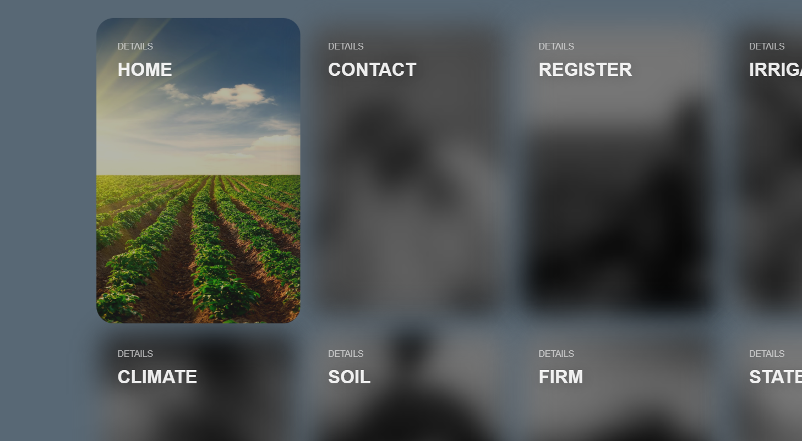

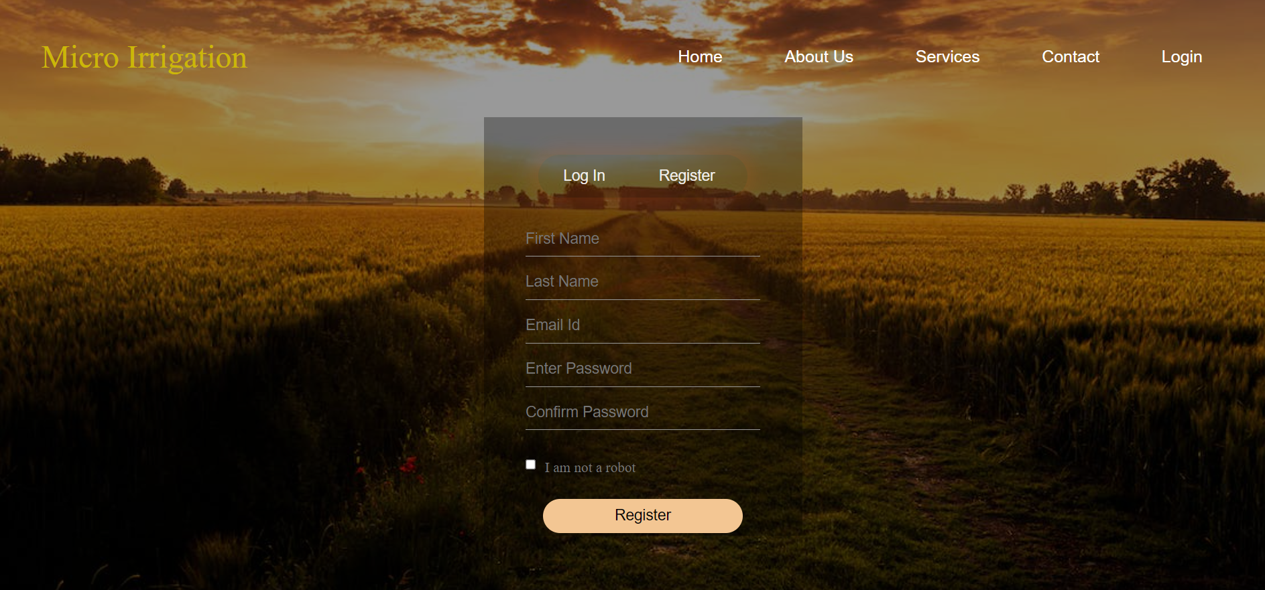

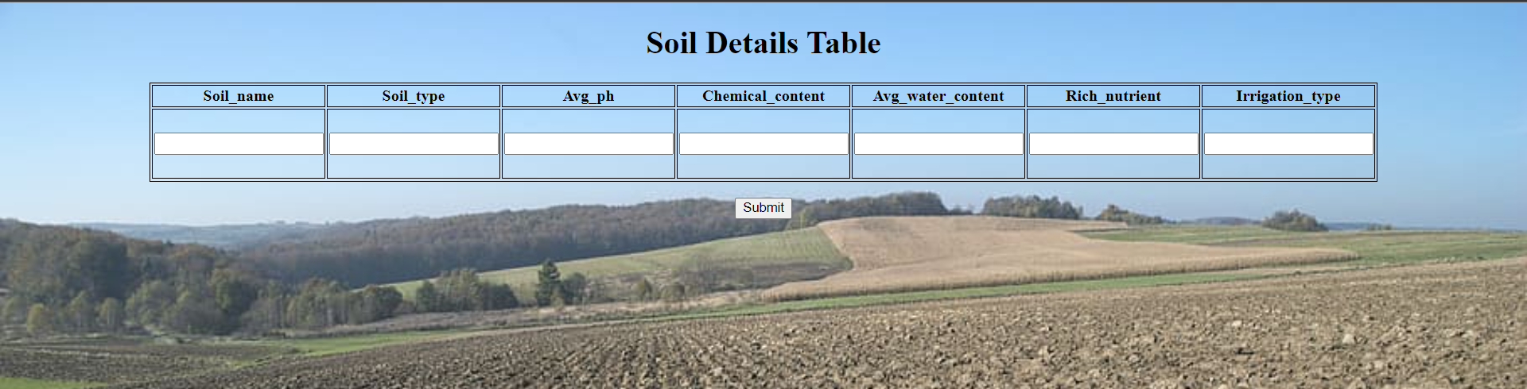

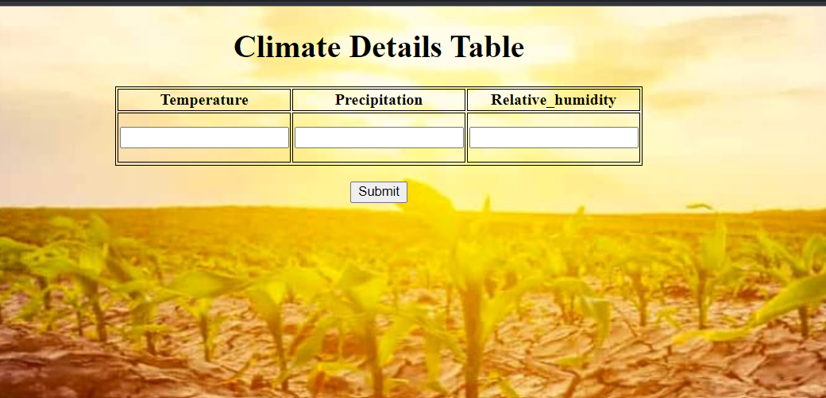

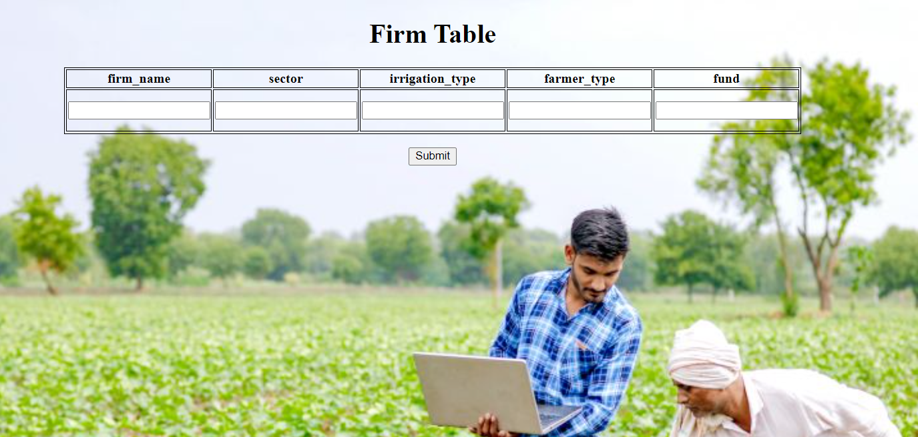

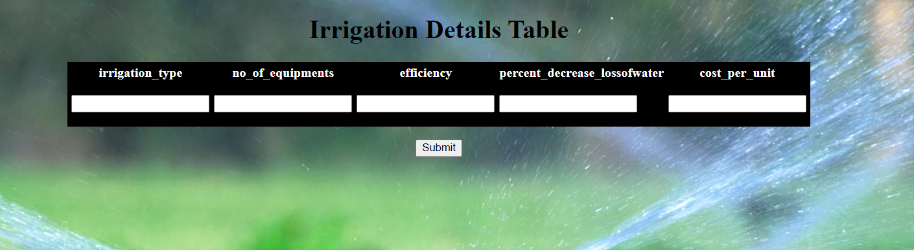

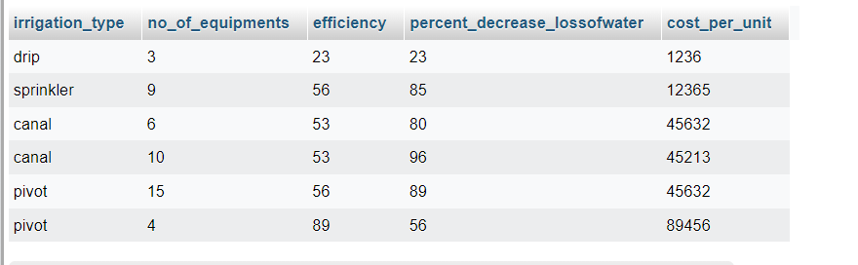

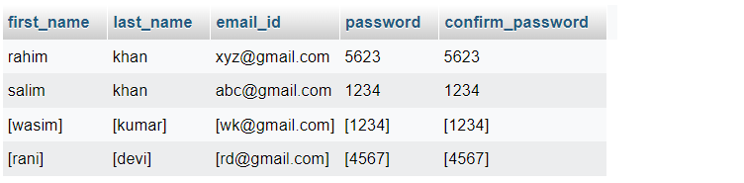

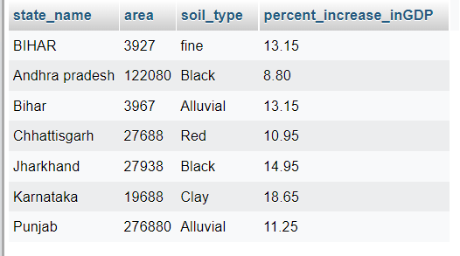

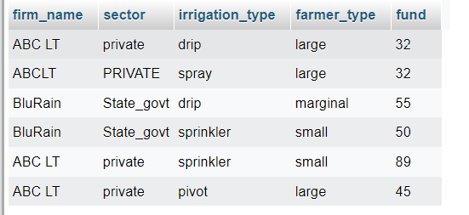

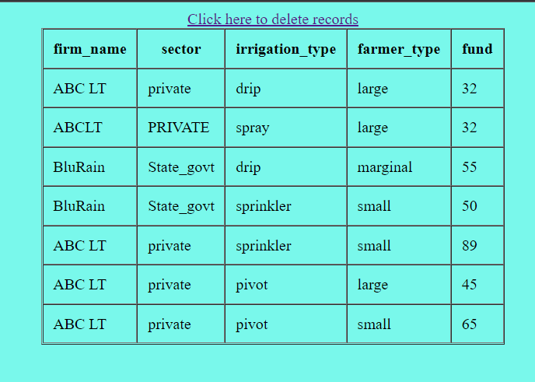

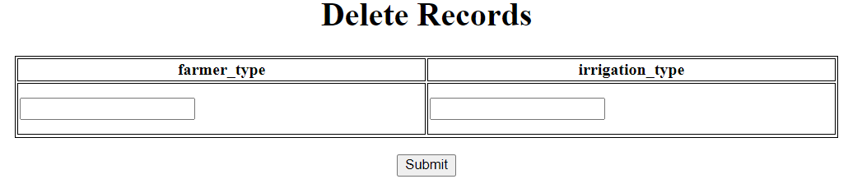

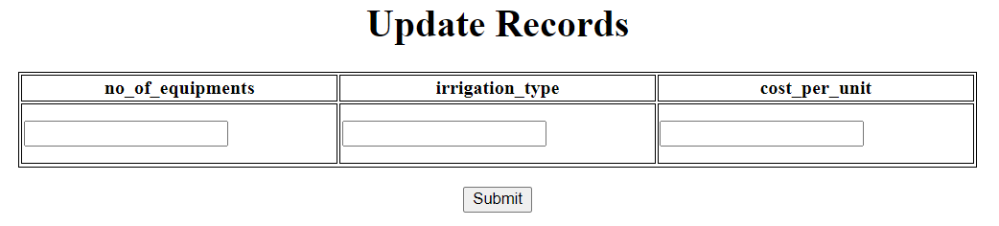

**Chapter 7 Analysis of data and report generated**

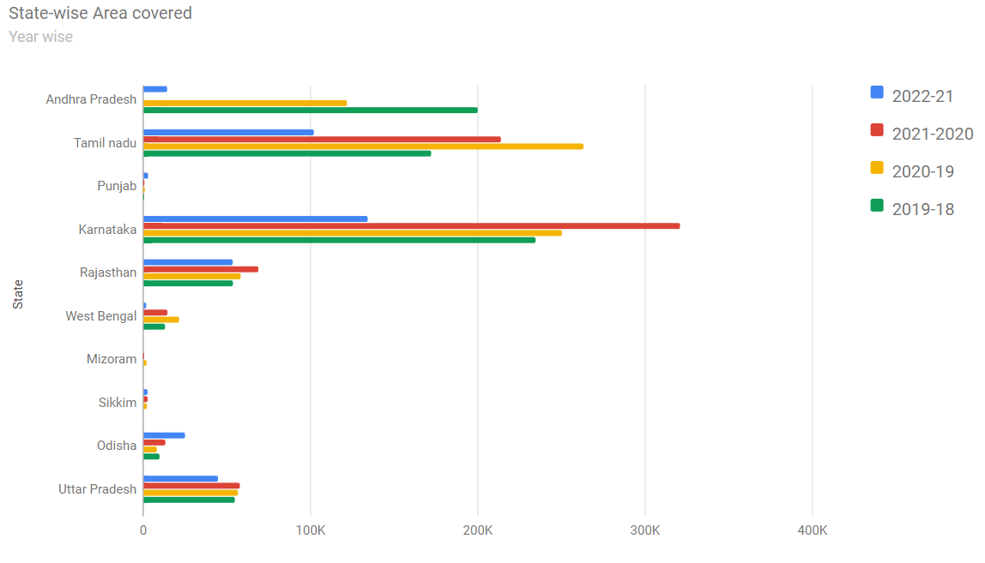

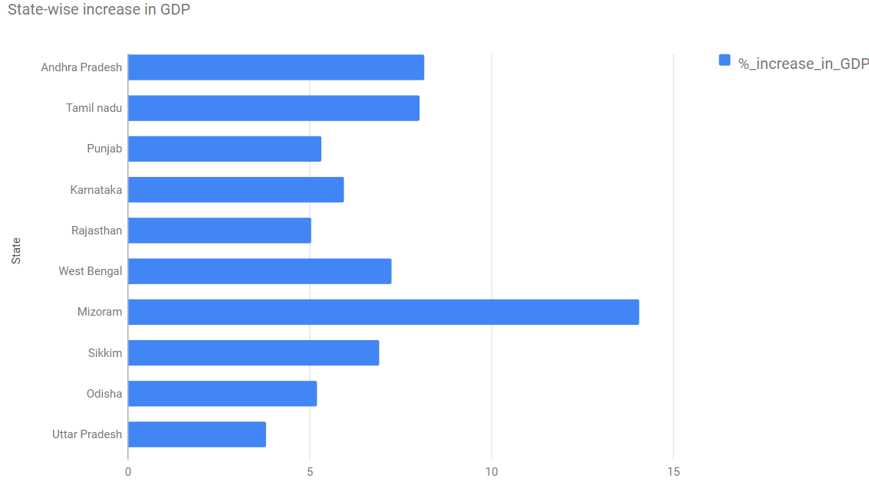

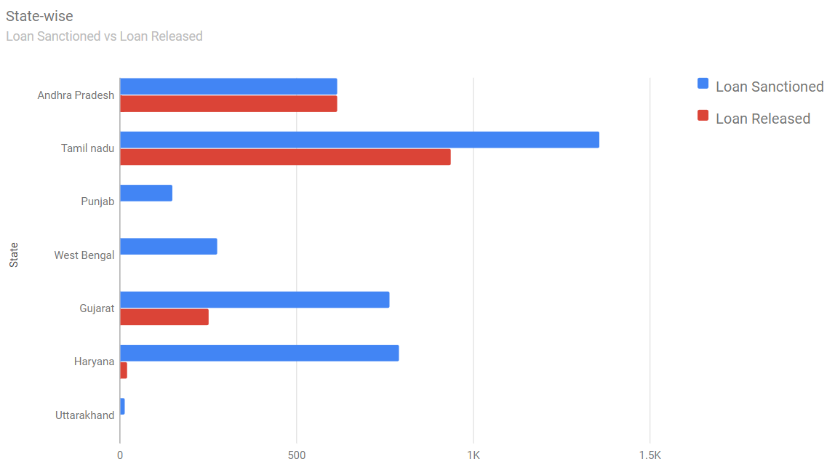

**Connectivity code:**

<?php

include('farmer.php');

$query = "SELECT firm_name, sector, irrigation_type,farmer_type, fund FROM firm";

$result = $conn->query($query);

?>

<body style="background-color: #20f4df99">

<div>

<table border="1" cellspacing="0" cellpadding="10" align="center">

  <tr>

    <th>firm_name</th>

    <th>sector</th>

    <th>irrigation_type</th>

    <th>farmer_type</th>

    <th>fund</th>

  </tr>

<center><a href="delete.html"> Click here to delete records </a></center>

</div>

</body>

<?php

if ($result->num_rows > 0) {

  $sn=1;

  while($data = $result->fetch_assoc()) {

 ?>

 <div background="https://i.gifer.com/origin/f6/f6597675d7799379b6d61bdeb79a91b9.gif">

  <tr>

   <td><?php echo $data['firm_name']; ?> </td>

   <td><?php echo $data['sector']; ?> </td>

   <td><?php echo $data['irrigation_type']; ?> </td>

   <td><?php echo $data['farmer_type']; ?> </td>

   <td><?php echo $data['fund']; ?> </td>

 <tr>

 </div>

 <?php

  $sn++;}} else { ?>

    <tr>

     <td colspan="8">No data found</td>

    </tr>

 <?php } ?>

 </table

**Demo Video:**

https://1drv.ms/v/s!AhyClrlp1j__gnHB4-38vQuNzaCA?e=fMea9m

**References**

[#] Per drop more crop, “Per drop more crop,” Wikipedia [Online]. Available: https://en.wikipedia.org/wiki/Micro-irrigation